1. What is software ? What is software engineering?

> Software is a collection of programs, data, and instructions that tell a computer how to perform specific tasks. It can be classified into different types, including , system software , application software , middleware , development software.

> software engineering is a disciplined approach to designing , developing , testing and maintaining software application. It applies engineering principal to insure that software is reliable , efficient ,scalable ,and cost-effective.

* 4 What is DFD? Create a DFD diagram on Flipkart.

A **Data Flow Diagram (DFD)** is a visual representation of how data moves through a system. It shows inputs, processes, data stores, and outputs to help understand system functionality.

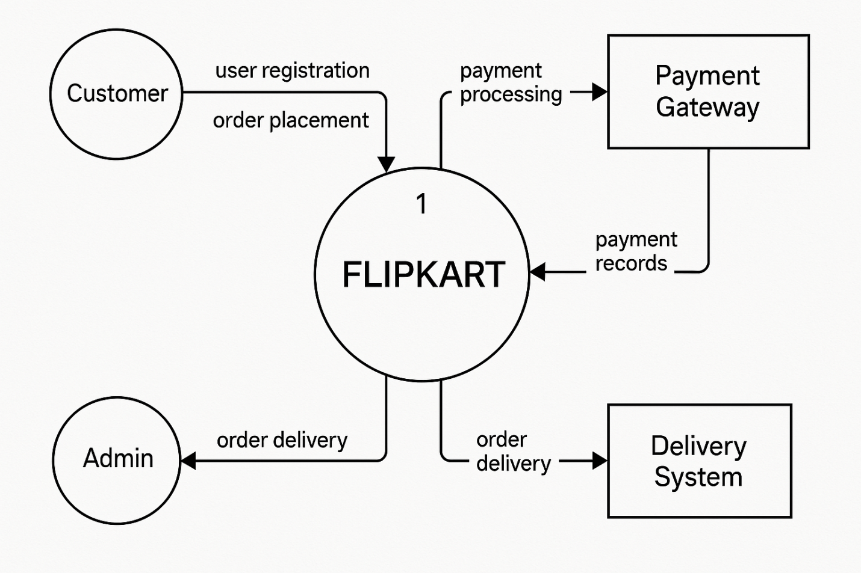5. What is Flow chart? Create a flowchart to make addition of two numbers.

>. A flowchart is a visual representation of a process or algorithm using symbols like arrows, rectangles, and diamonds to show the flow of steps sequentially.

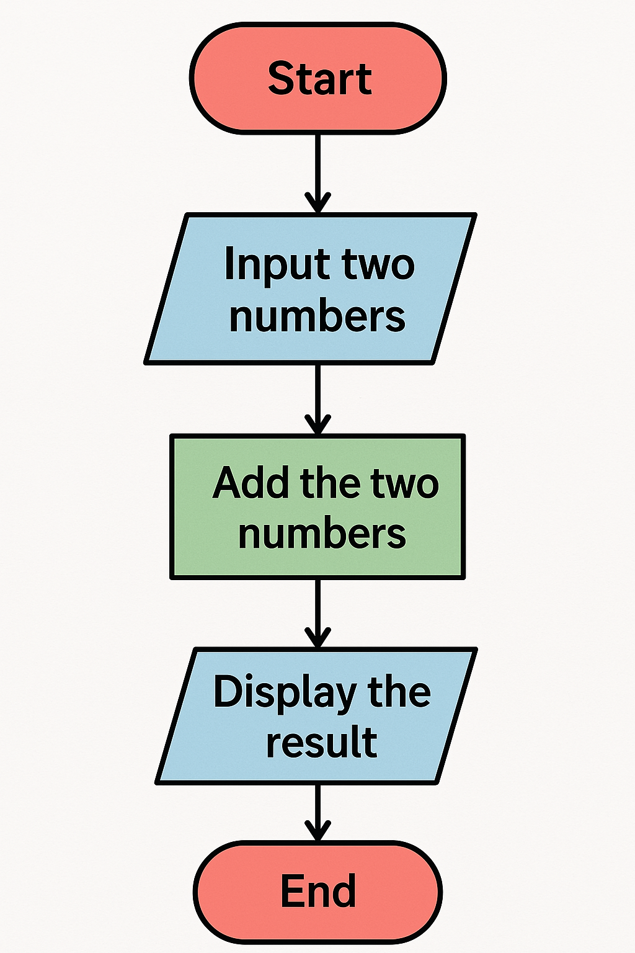

6. What is Use case Diagram? Create a use-case on bill payment on paytm.

* A **Use Case Diagram** is a visual representation of the interactions between users (actors) and a system, depicting how users achieve their goals using the system. It includes actors, use cases, and relationships between them.

